Paper Title
Academic Title and Name Author 1, University/Company, Department and Work Areas
Postal Address, e-mail: …@...
Academic Title and Name Author 2, University/Company, Department and Work Areas
Postal Address, e-mail: …@...
Academic Title and Name Author 3, University/Company, Department and Work Areas
Postal Address, e-mail: …@...
Paper Type: Scientific Paper or Practical Paper/ Case Study
Abstract
Purpose: Text Text Text Text Text Text Text Text Text Text Text Text Text Text Text Text Text Text Text Text Text Text Text Text …
Methodology/ Approach: Text Text Text Text Text Text Text Text Text Text Text Text Text Text Text Text Text Text Text Text Text Text Text Text …
Findings and Research Limitation: Text Text Text Text Text Text Text Text Text Text Text Text Text Text Text Text Text Text Text Text Text Text Text Text …
Originality/ Value: Text Text Text Text Text Text Text Text Text Text Text Text Text Text Text Text Text Text Text Text Text Text Text Text …
Keywords: Text; Text; Text; Text ...

Introduction
Text Text Text Text Text Text (Surname, year of publication). Text Text Text Text Text Text Text Text Text Text Text Text Text Text Text Text Text Text …
Text Text Text Text Text Text Text Text Text Text Text Text Text Text Text Text Text Text Text Text (Surname, year of publication). Text Text Text Text …

Heading Chapter 1
Text Text Text Text Text Text (Surname, year of publication).

Table I: Text Text Text
… | … | …
… | … | …

Text Text Text Text Text Text. Text Text Text Text Text Text Text Text Text Text Text Text Text Text Text Text Text (Surname, year of publication). Text …
Text Text Text Text Text Text. Text Text Text Text Text Text Text Text Text Text Text Text Text Text Text Text Text (Surname, year of publication). Text …

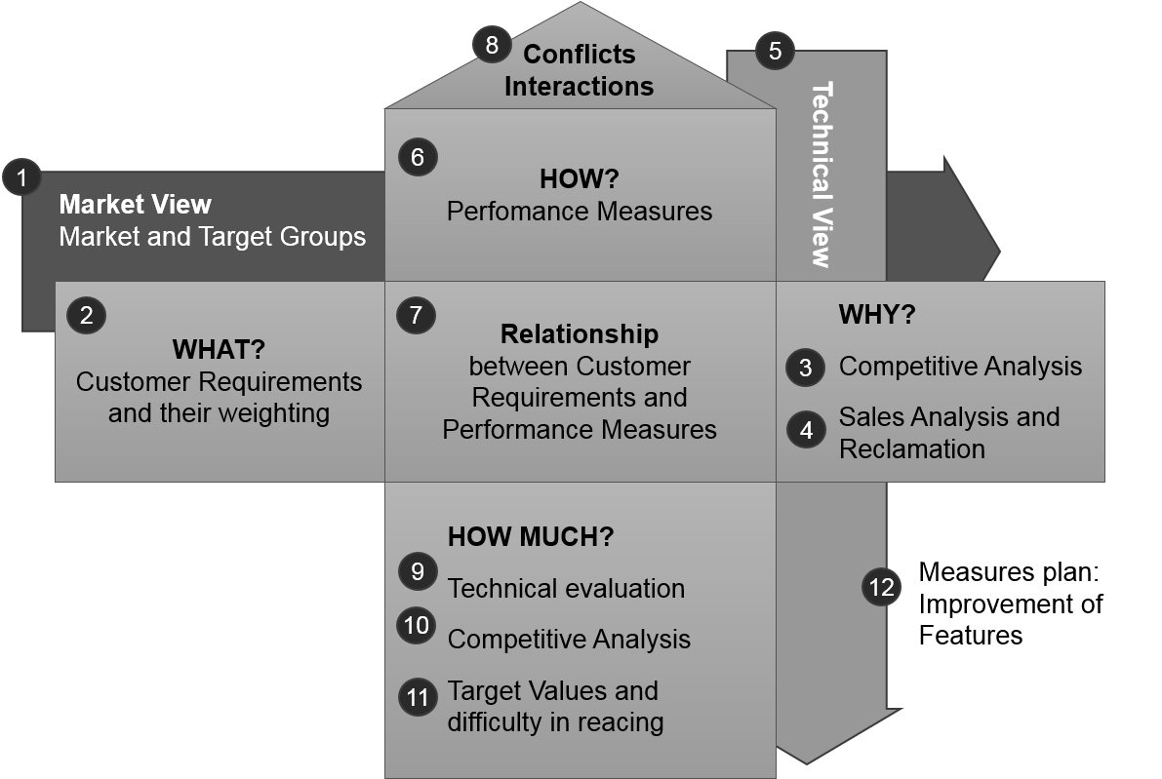
Figure 1: House of Quality

Text Text Text Text Text Text. Text Text Text Text Text Text Text Text Text Text Text Text Text Text Text Text Text (Surname, year of publication). Text …

Heading Chapter 2
Text Text Text Text Text Text (Surname, year of publication). Text Text Text Text Text Text Text Text Text Text Text Text Text Text Text Text Text Text …

References
Surname, Year | Surname, initials, (year), title of book, publisher, place of publication
Surname, Year | Surname, initials, (year), "chapter title", ditor's surname, initials,title of book, publisher, place of publication
Surname, Year | Surname, initials, (year), "title of article", journal name, volume, number, pages
Surname, Year | …

